Assignment 4.2

Verilog Design of 8 x 16 Register File

Register File Specification:
- A register file consists of 8 registers, each register of 16-bit width.
- The register file has read data bus(RdData), write data bus(WrData) and one address bus (Address) used for both read and write operations.
- Each register can be read and written by applying a register address to be accessed.
- Only one operation (read or write) can be evaluated at a time.
- Write Operation is done only when WrEn is high
- Read operation is done only when RdEn is high.
- Read and Write operations are done on positive edge of Clock
- All the registers are cleared using Asynchronous active low Reset signal

Block Interface: -
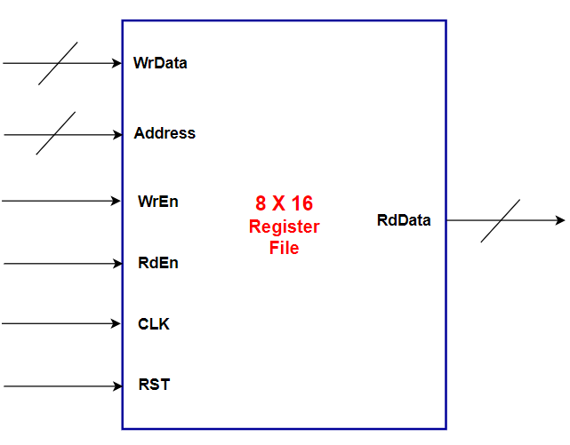
Hint: To clear the register using asynchronous reset signal, you need to put the reset condition the first one as following example

always @(posedge clock or posedge rst)
begin
if(rst)
begin
Reg_File[0] <= 16’b0 ;
Reg_File[1] <= 16’b0 ;
…………
Reg_File[7] <= 16’b0 ;
end
else
………………

Hint: You do not need to make this code parameterized for simplicity.
Hint: Let Session_4/Lab_2 is your starting point for this assignment

Requirements: -
1- Design a register file with the above specifications using Verilog language and determine Read and Write data buses width and address bus width.
2- Write a testbench to validate your design including at least 4 scenarios two for writing in the registers and two for reading from the registers.

